**Front-End Web Programming Web Programming 420-931-VA**

*-Assignment Web Site Yateng Geng_2295279*

1. Project Proposal to be submitted Oct 12, 2022

* Outline the project’s

1. Purpose( why is it being developed )
2. Applicability( who will use the system, and how will they benefit? ), and
3. Goal( what functionality do you want to develop? )

*1）Purpose( why is it being developed )*

I would like to build a clothing retail website for a particular local brand, since I do had some experience in this industry which will help me on developing the details of the website. And personally I consider this kind of website will cover mostly the functions of a website, which would be challenging myself and on the other hand will be a good way to improve my skills on building a website from 0 to 1.

1. *Applicability( who will use the system, and how will they benefit? )*

For this part, I guess the most benefit will be given to the customers. In my designing draft, i will create couple of functions that will give different discount or advantages for the customers who using this website. And for the manager of this specific local brand, I would like to design this website as well as their warehouse management system, they can easily to get the inventory data and of course the selling date to help them to find out what style or price area is more popular, so that they can make decisions for the next season or next year base on the data from the website.

1. *Goal ( what functionality do you want to develop? )*

For the goal, first of all there will be a home page showing welcome message, and there will be some new arrival items direct link, and maybe some on sale items, or occasional discount information and links to different pages. And also there will be a menu or navigator for different part of the website, it will including basically 8 options:

1. On the top of this menu will be the “New Arriving” tag, click on this will lead to a page that will only showing the items that are added withing 10 days.
2. After the “New Arriving” will be the “ON SALE” tag, will lead to a page which will shows only the items that added 45 days ago and still not sold out, and all the item here will automatically apply a 30 percent discount.
3. Then will be the “ Men ” tag takes you to the page which will show you only the clothing for men.
4. Next will be the “ Women ” tag, of course show you the page that will only give you the clothing for women.
5. And there will be tag for “ Kids ”, as well as “Women” tag, this one will show you only the clothing for kids. If we want we can add a sub_tag on this, to separate “ Boys ” and “ Girls ”.
6. Then we will have a “ Register Now ” option, take users to a registration page, after registration they will enjoy a 5 percent discount for the whole website. And of course we will have a “ Log In ” button on somewhere of the home page ( could be the right to corner ).
7. I would like to have the “ Reserve Now ” tag to add the reservation function, normally this kind of website will not have this tag, just for invoking myself to practice on this function.
8. The last tag will be “ Join us ” which will link to a new page showing our opening position in store. Users can submit their CV on this page to apply for a specific position.
9. Web Site State of Progress to be submitted Oct 24, 2022

Finished the items template cost most of time to do so, with this template will be able to add all the other items in the same form, just modify some details.

Finished the Register page with Web Table and Web Form as well.

Modified the links between different pages, you can go to different pages from anyone.

To check the item template, you can simply click on anyone of the three links

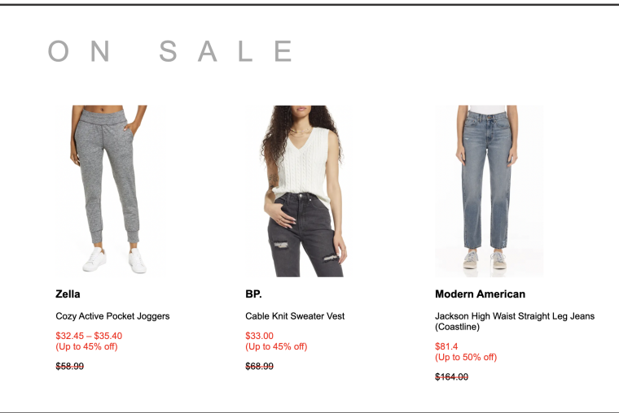

The register page:

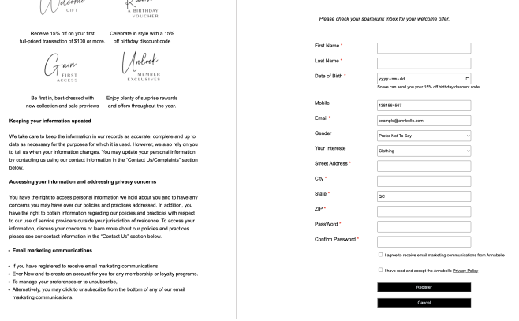

And the foot for all pages:

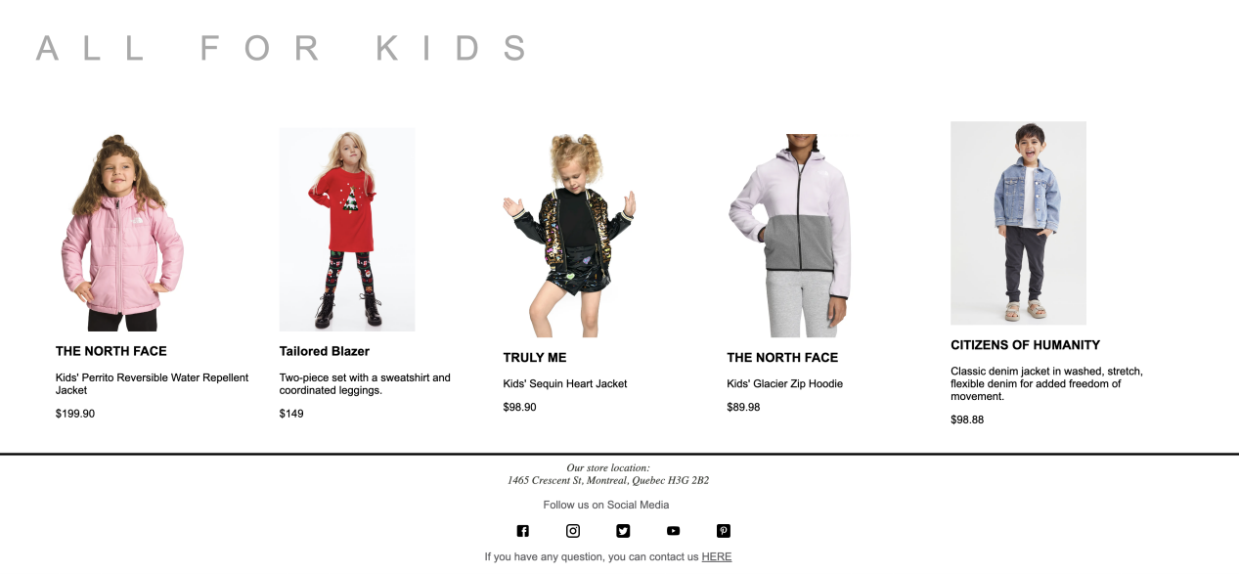

C. Final Project Web Site to be submitted at the end of due date: Nov 18, 2022

Finished all 8 main pages and all items detail pages (more than 20 pages), in each page you can skip to all other pages by click on the navigating bar, there are different items belongs to each particular category. For example all the items in New Arriving page is having a *New!* Mark shows in front of the title, you can simply click on each item to check the details.

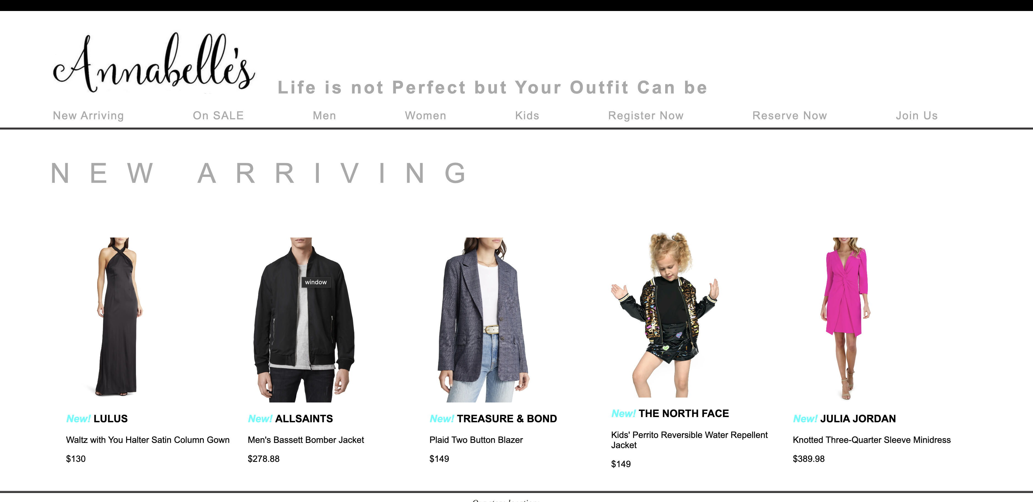

Besides the same header for each page, there is a same footer for each page, in the footer you can find the address, social medias and also the e-mail link here. For the social medias you can click on these icons will lead you to different social website.

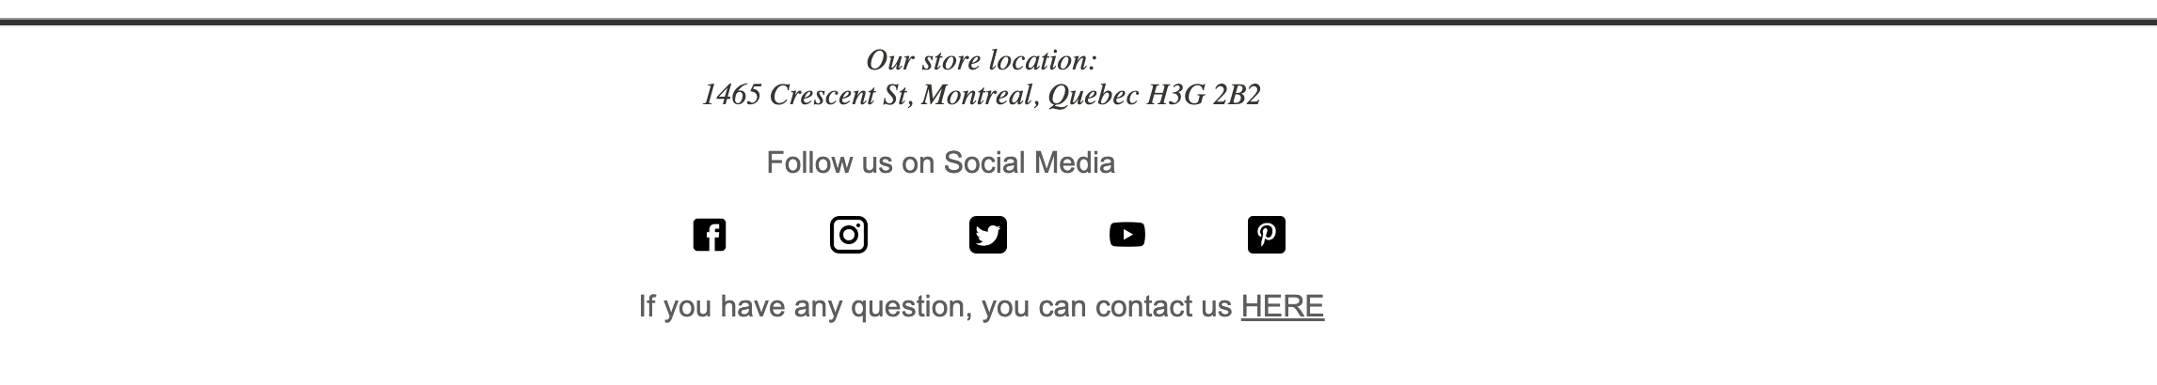

In the home page, finished all items detail pages, you can click on each one go to the details, click on the main image will take you to the new Arriving page. The logo image in each page will take you back to home page.

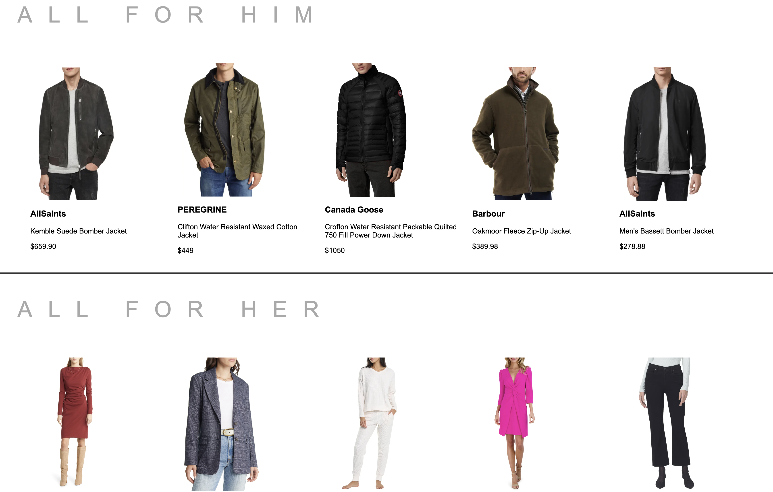

And also finished all items details pages, there is an image gallery for each item, click on the small images will show you the big image on the main position. Here is using Java Script function. For the right side, using table and nested input tag build up, you can select color, size and ship or pick-up in store.

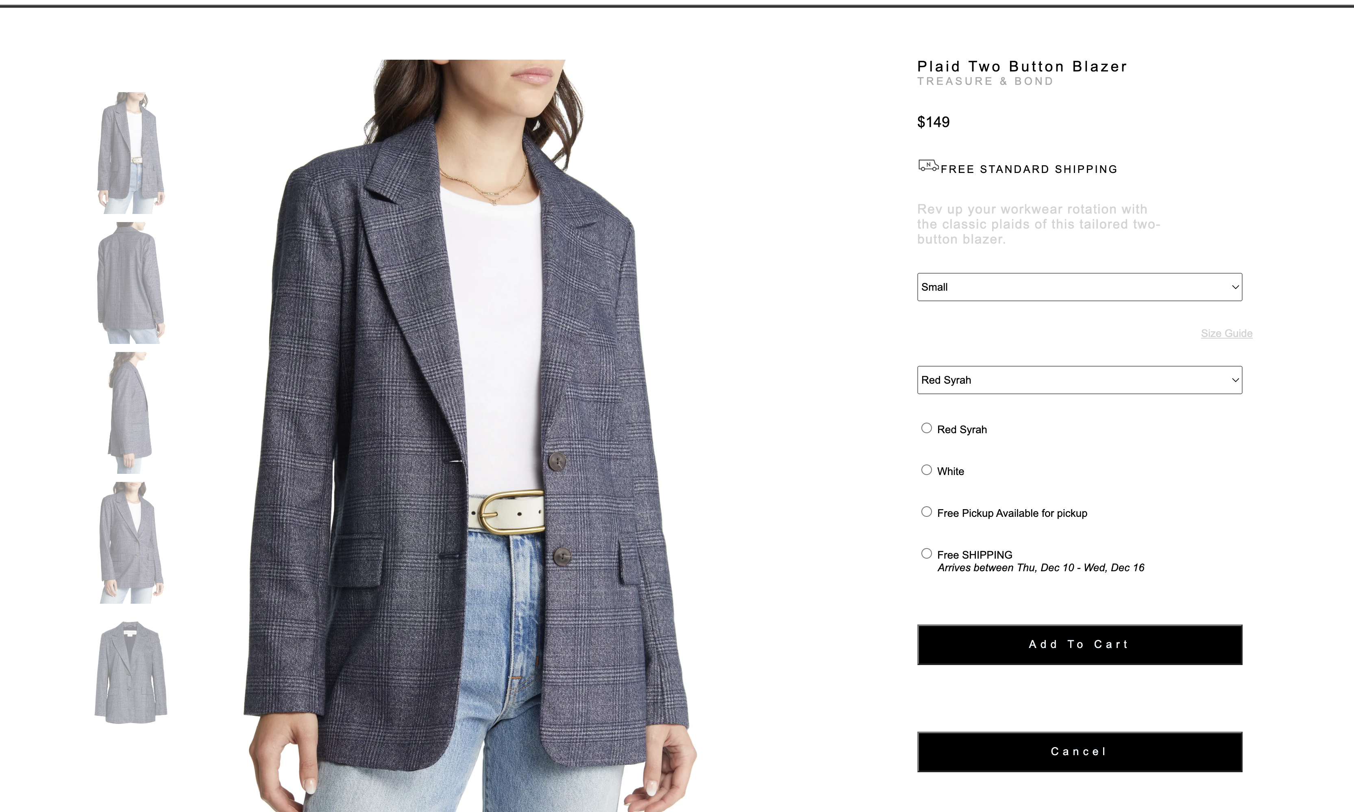

For the register page, finished all details, basically build the left part using a table and divs, the right side is the key, build up with a form, user can enter data here and click on the Register to be a member and also user can click on cancel to clear up the data, if they already had an account they can log in using the Log In link. By clicking Register, the page will pop out a message saying “Thank you”. And for reserve page, kind of same as this page, just changed the text and part of the form, user can choose there prefer visit date and fill up the information, by clicking on the confirm button, will pop out a message stating “Your Appointment at + the date user chosen + is confirmed! Thank you” as showing below.

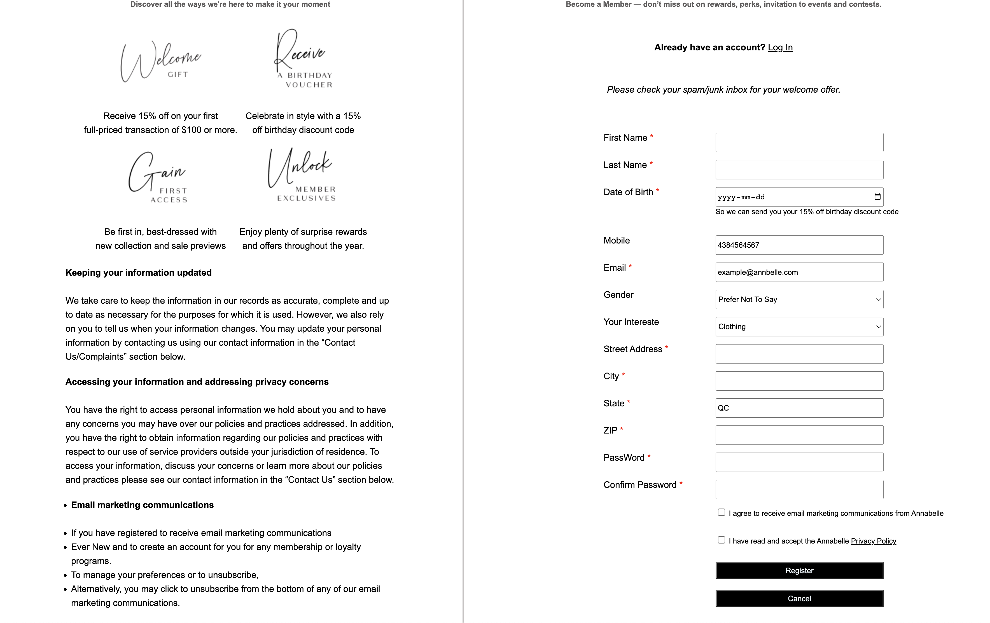

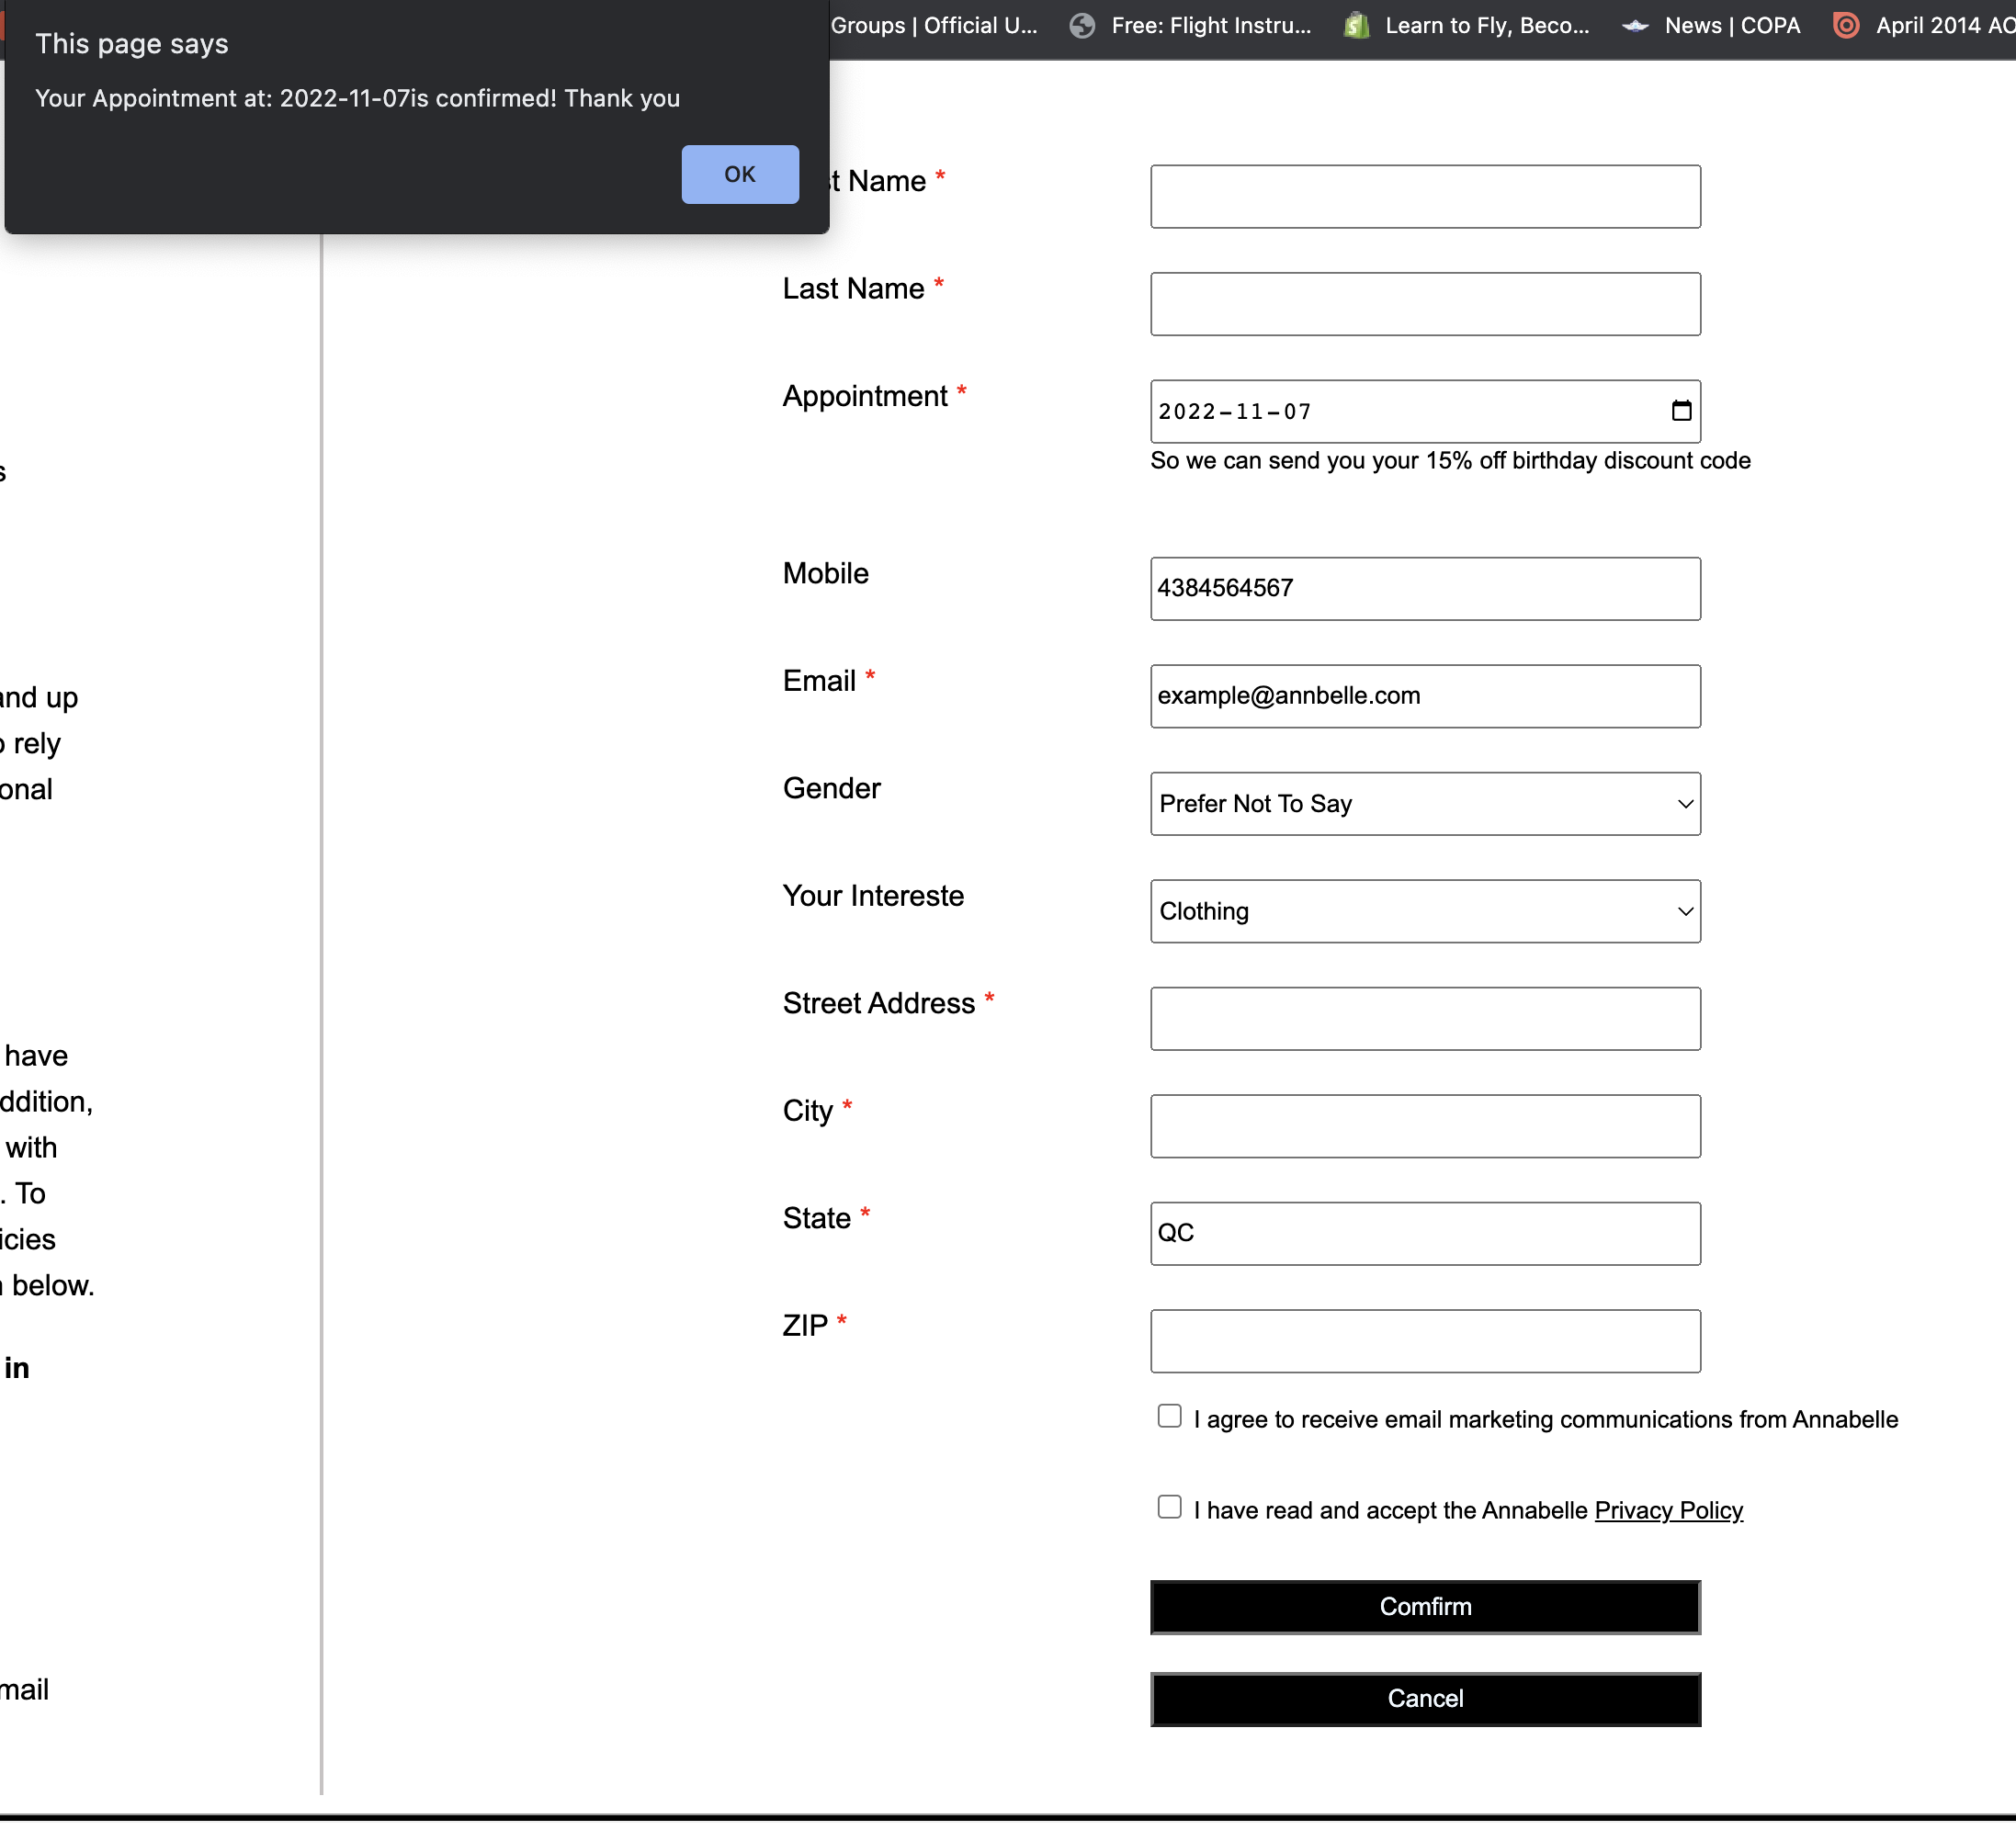

For the Join Us page, there is a video (using iframe tag) of introducing our company, following the video is text stating what we offering for our new joiner, and following by a table of opening position. Also the right hand of the page is a form need applier to fill up, user can chose what position they are applying and also they can upload their resume here. By clicking the Apply button, page will say “Thank you!”

